**User Manual**

ConfMS is an application that allows you to create and manage conferences. Here you can upload information about your conference and anyone who is interested can join it.

For those who are into research and want to share their knowledge, this app will help them find the conferences suitable for their papers. And then, the reviewers in the Program Committee will decide the papers that will be presented at the conference.

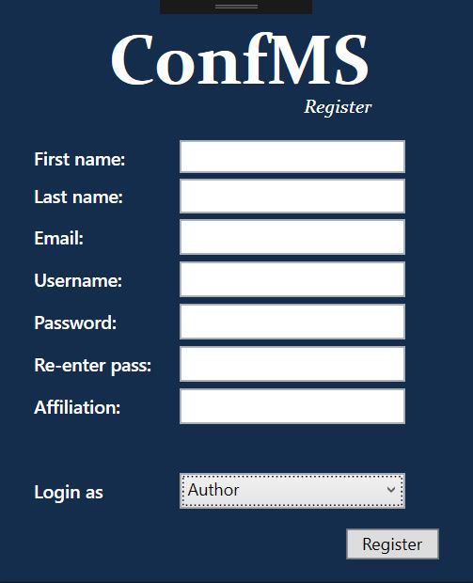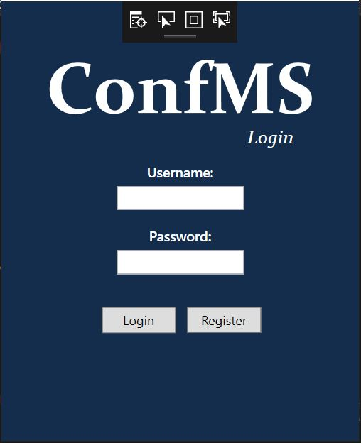

*The start page The register page*

**The regular user:**

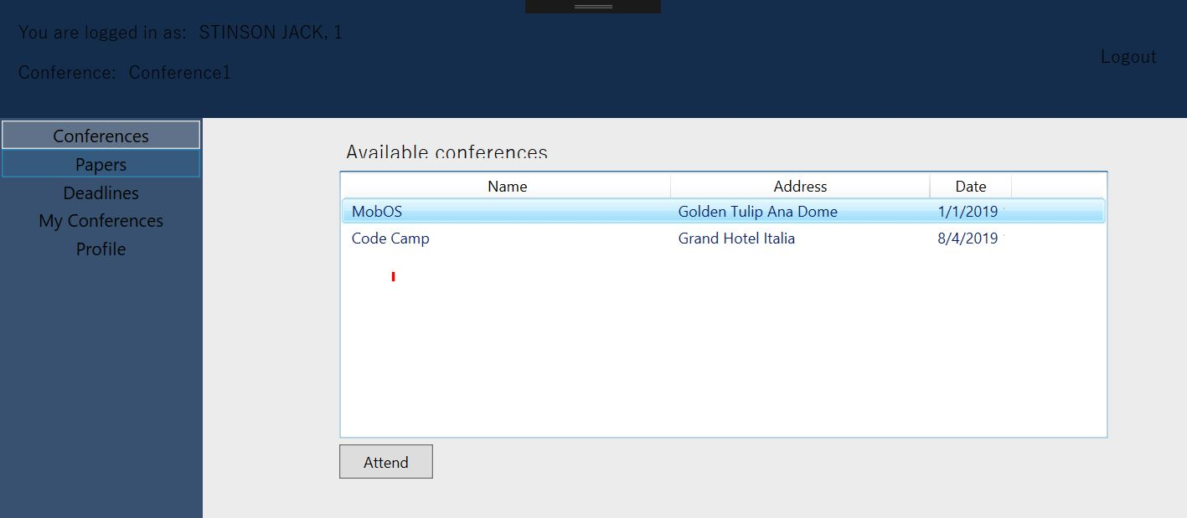Anyone can create an account as a regular user (listener). This user role allows you to see the upcoming conferences and join them.

*All conferences page*

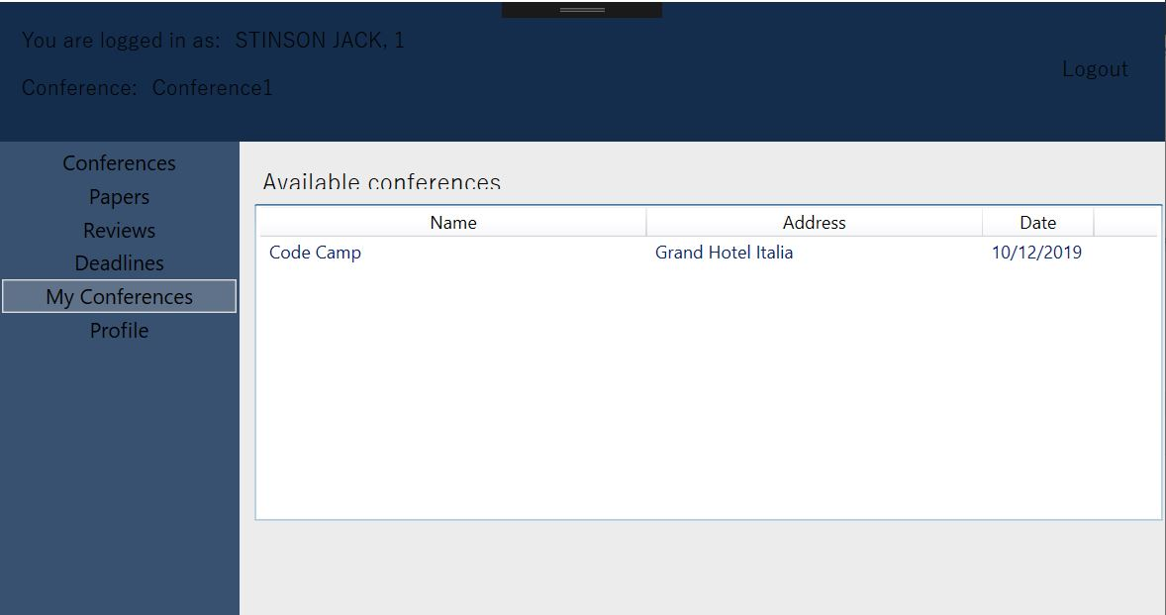

*The conferences this user has chosen to attend*

**The author:**

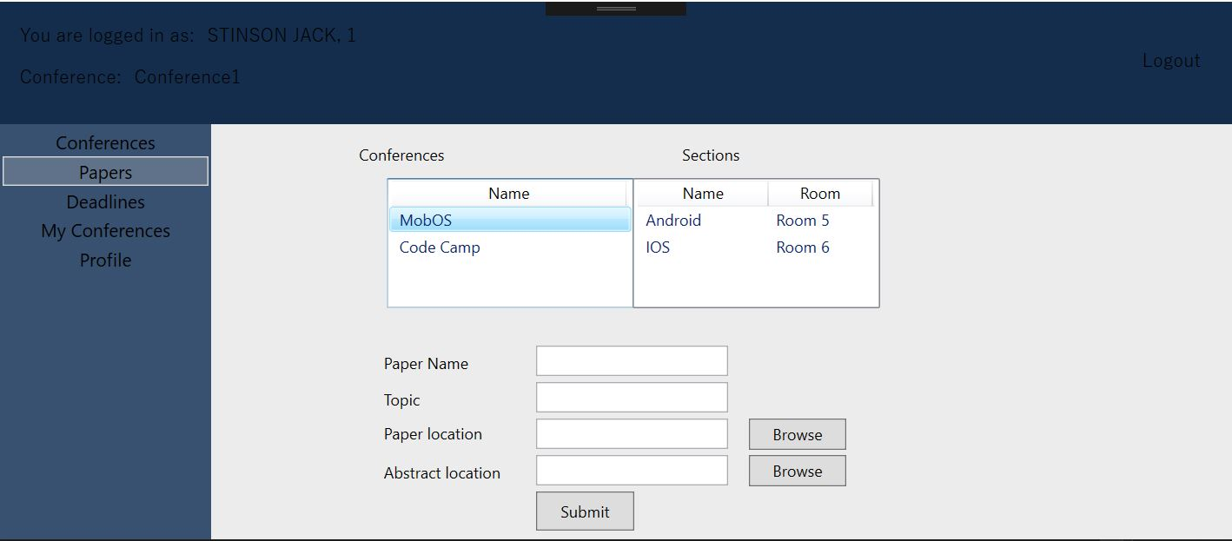Apart from seeing and attending conferences, an author can also submit papers by submitting a paper or an abstract.

*Here, the author can submit a paper*

**Program Committee Member:**

This is a special role, meaning that only those who have already been chosen in the program committee can create an account as a PC Member. This role gives you the possibility to also change (postpone) deadlines.

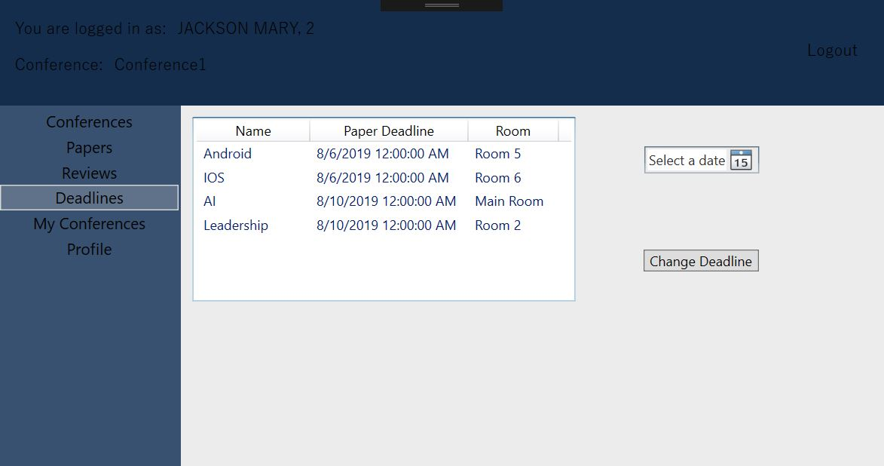

*Deadlines page*

The regular PC Members (those who are not chair nor co-chair) can also see and choose to review the submitted papers. Based on the qualifiers obtained, the reviewers will decide if the paper is accepted for the conference or not.

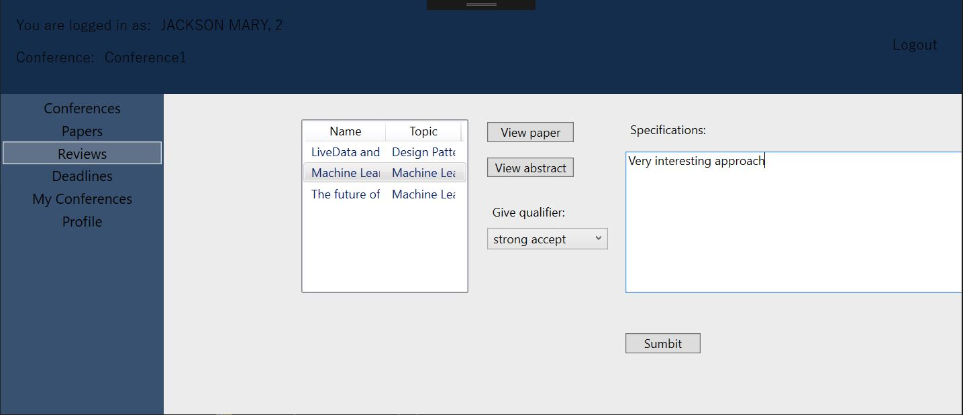

*Review page*

If the reviewers have contradictory opinions about a paper, the chair and co-chair can ask them to re-evaluate it.

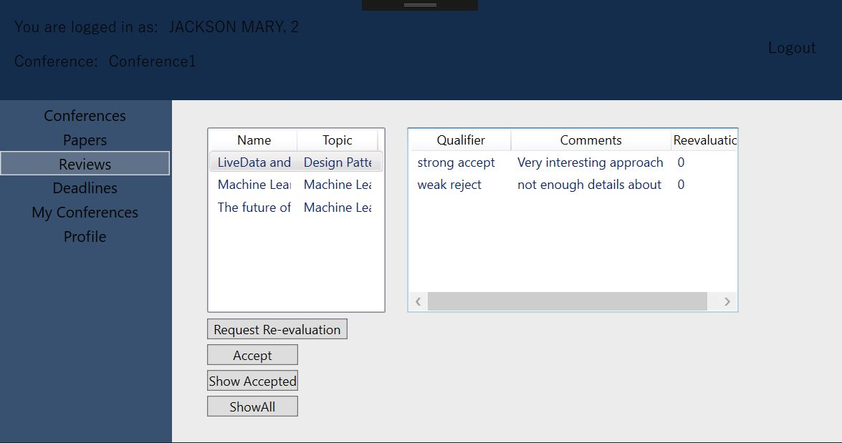 *The chair and co-chair can see the reviews and ask for re-evaluation*

**The steering committee**

Logging in with a steering committee account allows you to create conferences, add the members of the Program Committee and assign the Sections for a Conference.

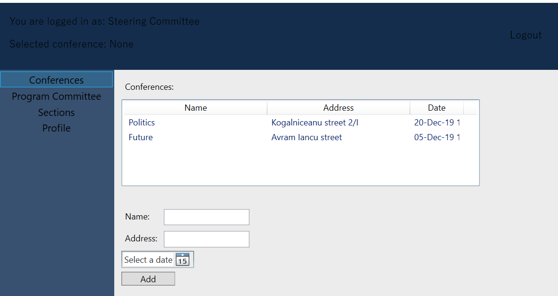

*Here, a steering committee member can add a conference*

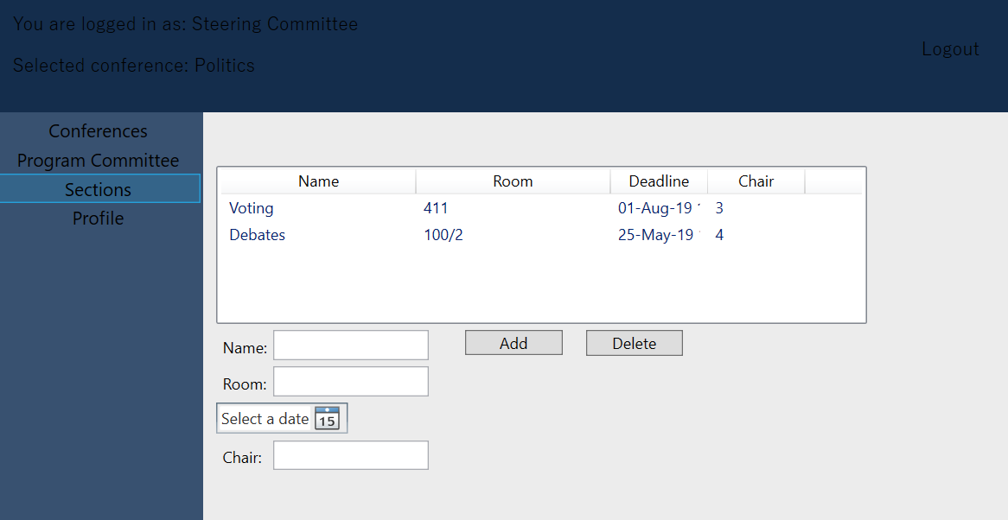

*The steering committee adds sections to the selected conference*